**User interface and design**

Lab experiment 5

**Conduct task analysis for an app (e.g., online shopping) and**

**document user flows. Create corresponding wireframes using**

**Lucidchart**

**AIM:**

To understand and document the steps a user takes to complete the main tasks within an Online shopping App.

I have designed a simple ecommerce website in figma with simple layout .

This is the link of my design.

https://www.figma.com/design/GXxfla54NKREePHxFhu0pB/experiment-4?node-id=0-1&t=QoMbBJj4YSictVSv-1

I have designed a simple layout with login or register, a search option,

add to cart, reviews section, payment.

I used lucidchart to create the flow chart of the website.

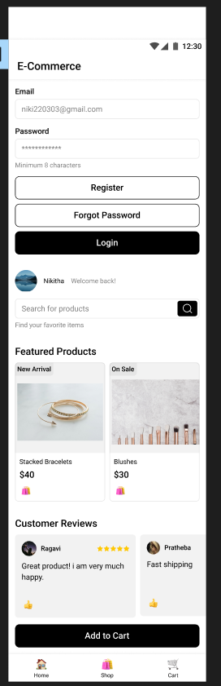

Flowchart :

The flow of the ecommerce website is:

Login/Register Flow

Steps:

○ Open the app

○ Click on "Login" or "Register"

○ Enter details

○ Verify (if required)

○ Redirect to the home screen

Browse and Search Flow

Steps:

○ Navigate to categories or use search bar

○ Apply filters/sorting options

○ View product details

Add to Cart Flow

Steps:

○ View product details

○ Select options (size, color, quantity)

○ Add product to cart

Checkout Flow

Steps:

○ Review cart

○ Proceed to checkout

○ Enter shipping information

○ Select payment method

○ Confirm and place order

Order Tracking Flow

Steps:

○ Navigate to "My Orders"

○ Select order to track

○ View tracking details

I used diamond shape for decision making.

Oval for start and end.

Parellogram for input and output.

Rectangle for process.

This is the flowchart.

